GIT Installation Setup

* **Select Components** Make sure you leave turned on the check-box to install Git LFS (Large File Support).

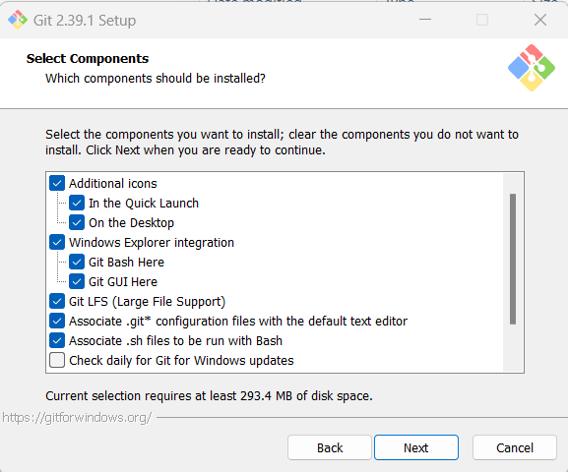

* **Choosing the default editor used by Git** I recommend that you install Notepad++ first, and during the initial installation of Git, select that as the default editor.

* **Adjusting the name of the initial branch** in new repositories Override the default branch name for new repositories, and set that to main (this is what we are using for the Flux repositories).

* **Configuring the line ending conversions** Make sure to select Checkout as-is, commit as-is. In short, we don’t want any LF to CRLF conversions or vice versa. We have a lot of text and HTML files in our test-data set that use Unix style endings and this conversion will cause tests to fail.

* **Configuring the terminal emulator** to use with Git Bash I found it simpler to use Windows’ default console window than to use MinTTY.

* **Choose the default behavior** of "git pull" Make sure to select Only ever fast-forward. This is especially important for folks like us who are coming over from Mercurial. By default a git pull will do a merge of the incoming commit, and that is usually not what you want unless we can do a fast-forward merge. The equivalent to a hg pull is really a git fetch and then one can do a git merge appropriately. I think this is definitely better than doing silent merges of the non-fast-forward variety.

* **Choose a credential helper** Pick the Git Credential Manager Core – this will make it easy to log in just once to Github and you will not keep seeing name and password prompts each time.

